AVR C – 영어단어 학습기(Atmel Studio - ATmega328p English word rotator on LCD)

PN: 23189815

차례

1 목적 2

2 코딩 시나리오 2

3 결과 사진 2

4 ATmel Studio 7.0 개발 환경 4

5 참조 6

6 코드 6

# 목적

Atmel Studio 7.0을 이용해서 아두이노 우노의 MCU인 ATmega328P에 직접 프로그래밍하는 방법을 설명한다. AVR C언어를 이용해서 아트멜 스튜디오에서 작성하고 컴파일된 코드의 hex 실행화일을USBtiny 프로그래머를 이용해서 직접 프로그래밍하는 방법을 설명한다.

아트멜사에서 무료로 제공하는 IDE의 도구에 외부프로그래머(USBtiny)를 연동해서 업로드하는 방법도 설명한다.

# 코딩 시나리오

영어 공부를 하면서 만나는 새로운 단어를 평소 공책에 적어두고, 이를 AVR C를 이용해서 2행 16열 문자 LCD 에 주기적으로 나타나게 한다. 코딩하는 재미도 있고, 더불어 심심할 때를 이용해서 영어 단어를 상기시키는 round-robin word memorizer가 탄생한다.

# 결과 사진

## USBtiny 프로그래머와 연결된 ATmega328p 보드

ATtiny13A 또는 ATtiny 85 MCU를 개발하기 위해 만든, 개발보드의 8핀 칩 소켓을 이용해서 I2C 통신 선로를 연결하였다.

USBtiny 프로그래머의 6핀 소켓 핀아웃 정보

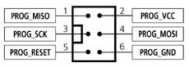

ATtiny13A 8핀 소켓 핀아웃 정보

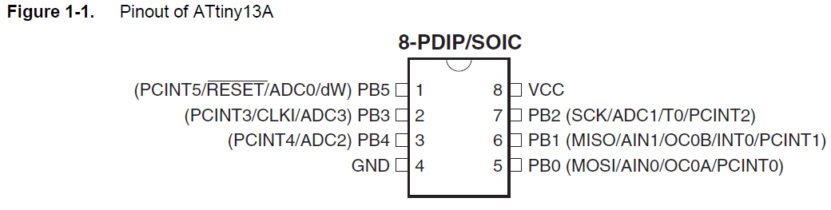

본 실험 사진의 전선은 흰: RST, 빨: Vcc, 노: SCK, 녹: MISO, 파: MOSI, 검: GND

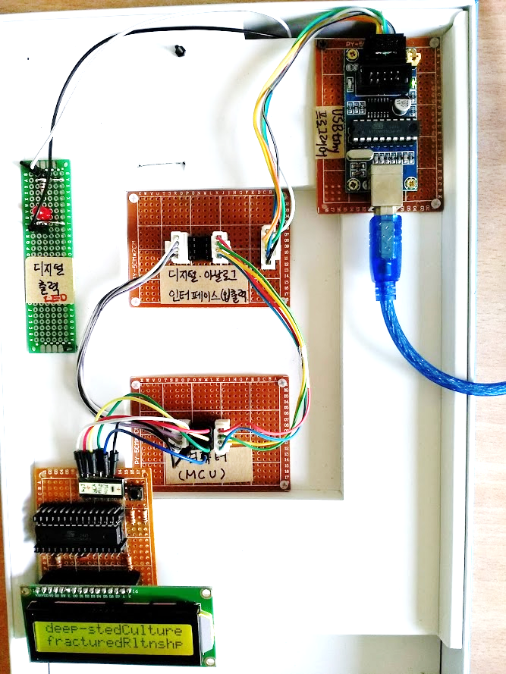

컴퓨터(MCU)보드의 8핀 소켓 위에 라운드 타입 8핀소켓을 덧 씌우고 점퍼선을 꽂으면 안정적으로 점퍼가 고정되고, 소켓 탈착도 편하다.

## ATmega328p 보드 확대

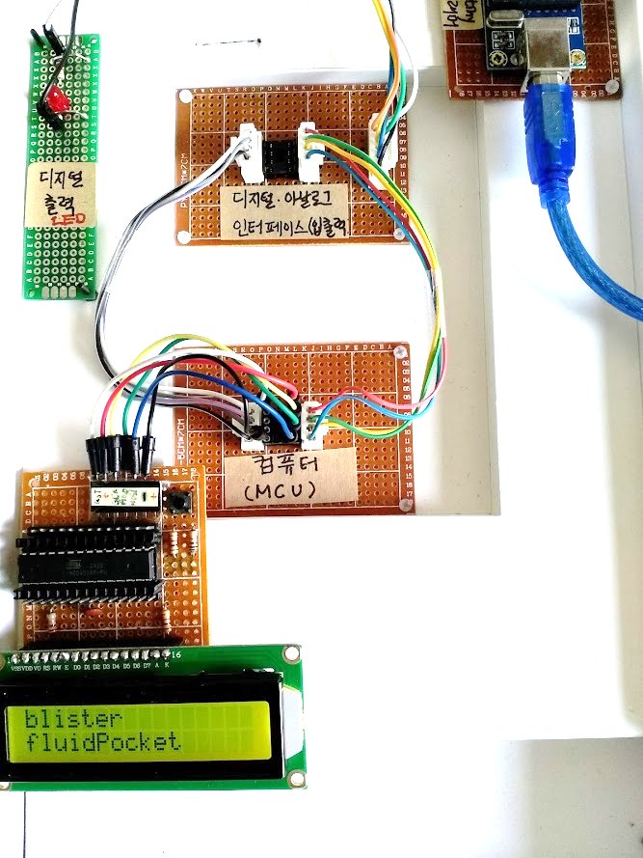

## 온습도 측정

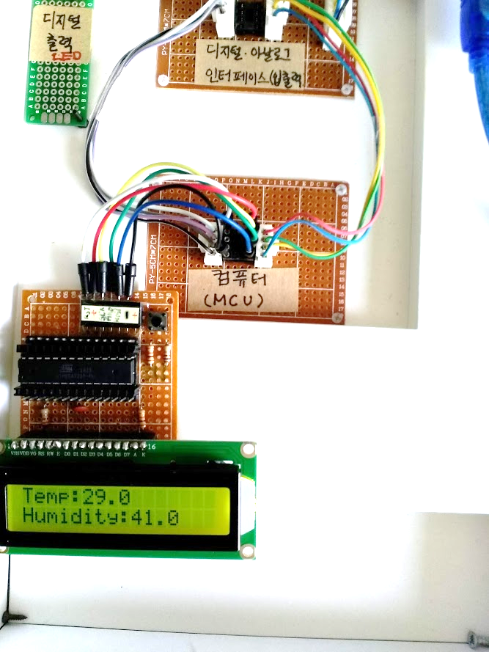

## 측면 (DHT11장착 상태)

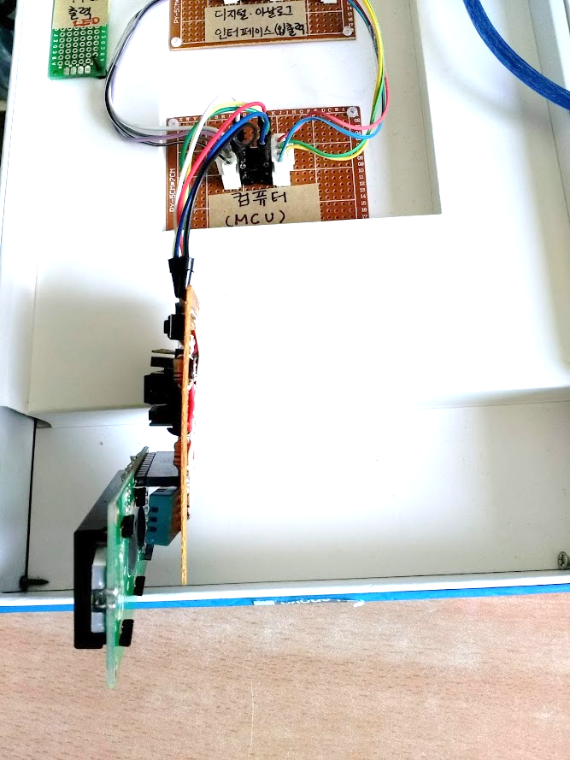

## 뒷면 배선 및 납땜

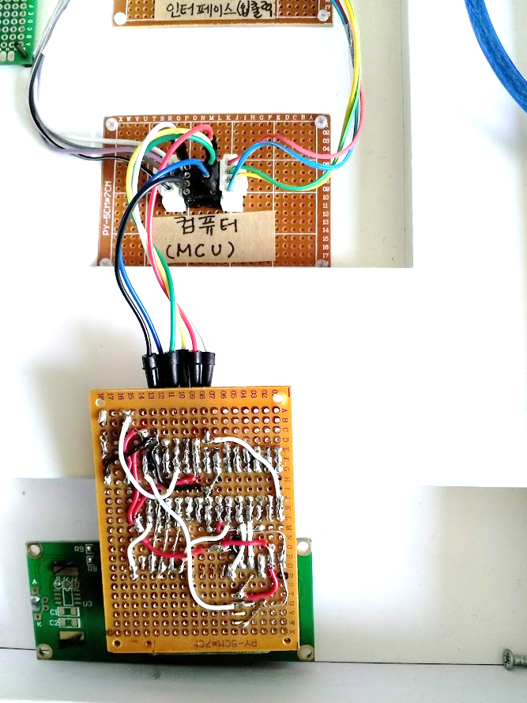

# ATmel Studio 7.0 개발 환경

## 코딩

F7을 누르면 컴파일

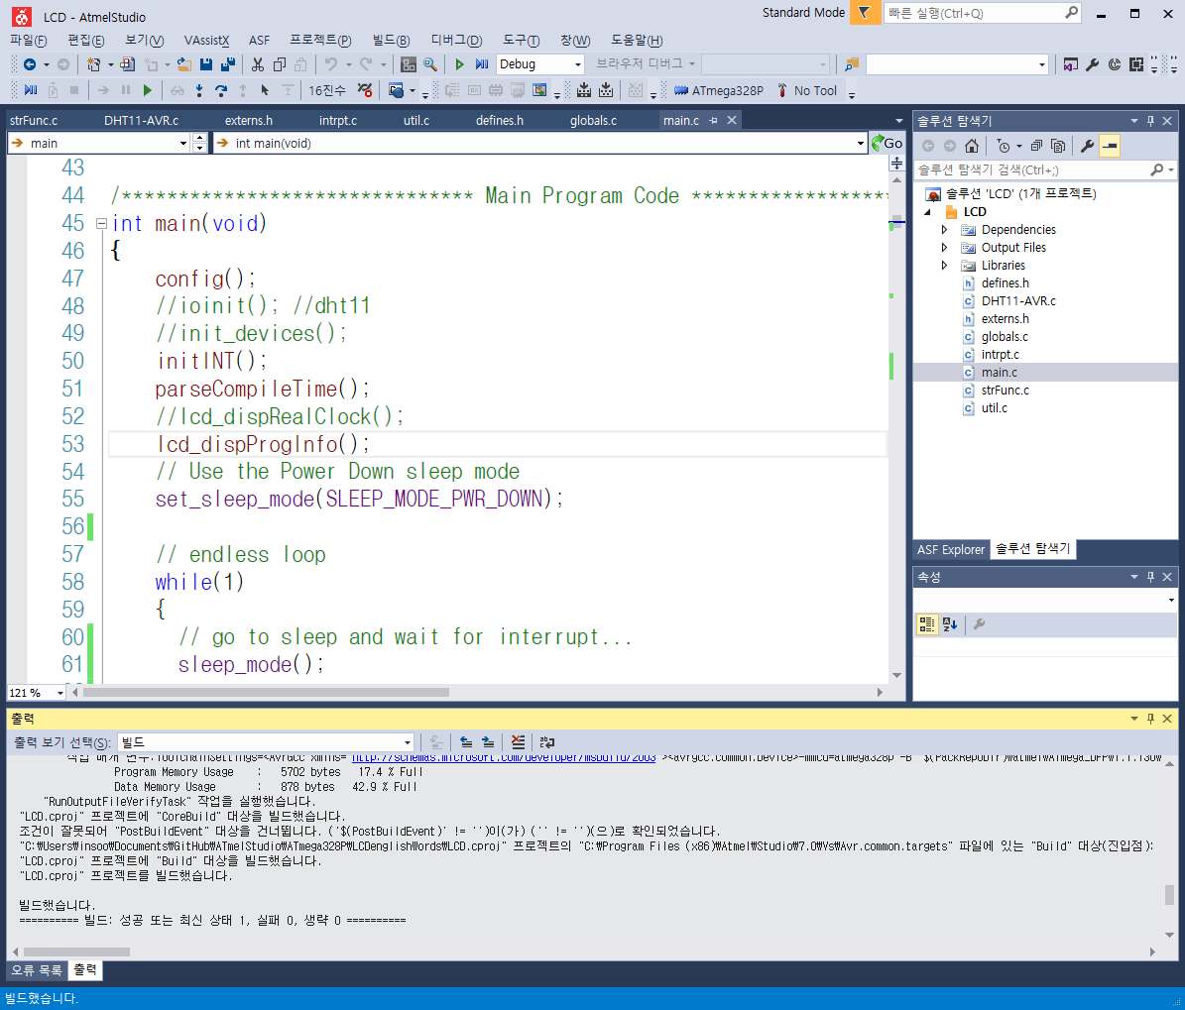

## 업로딩

메뉴 – 도구 – USBtiny : Alt+T, y

위 단축키는 사전에 도구메뉴의 외부도구 항목에서 설정해 주었기 때문에 가능하다.

제목: USBtin&Y

명령: C:\WinAVR-20100110\bin\avrdude.exe

인수: avrdude -c usbtiny -P usb -p atmega328p -U flash:w:LCD.hex:i

초기디렉토리: $(ProjectDir)\Debug

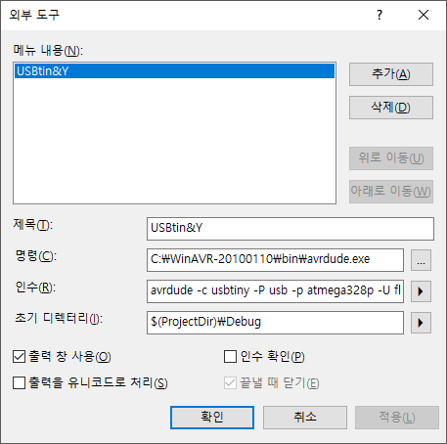

F7으로 컴파일 후 문제가 없음을 확인 한 후, Alt+T, y를 눌러서 USBtiny프로그래머를 통해 ATmega328p로 업로드 하면, Atmel Studio의 출력창에 업로드 진행 경과가 표시된다. 업로드 중에는 USBtiny프로그래머의 빨간 LED가 켜지고, 업로드 완료되면 꺼진다.

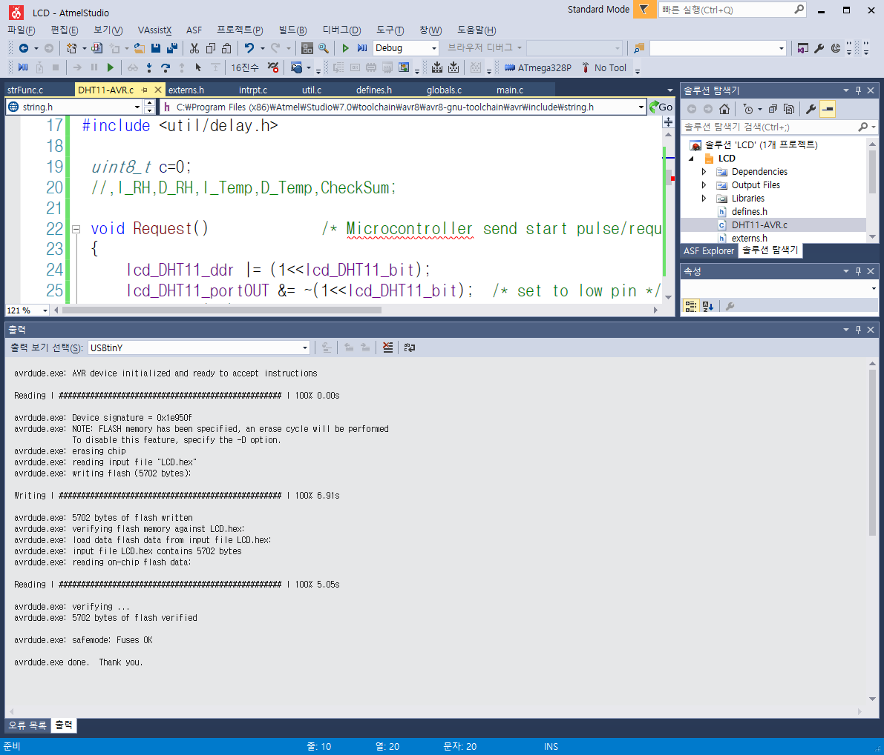

# 참조

## DHT11 AVR C코딩

<http://www.electronicwings.com/avr-atmega/dht11-sensor-interfacing-with-atmega16-32>

# 코드

## Main.c

/****************************************************************************

<For Windows Atmel Studio>

cd "Atmel Studio\7.0\ATmega328P\LCD\LCD\Debug"

OR cd "C:\Users\insoo\Documents\Atmel Studio\7.0\ATmega328P\LCD\LCD\Debug"

OR cd "C:\Users\insoo\Box Sync\BoxElec\DIY Electronics\Arduino\Codes Atmel Studio\7.0\ATmega328P\LCD\LCD\Debug"

avrdude -c usbtiny -P usb -p atmega328p -U flash:w:LCD.hex:i

*/

/**************************************************************

Target MCU & clock speed: ATmega328P @ 1Mhz internal

Name : main.c

C modules of this project, LCD:

main.c globals.c intrpt.c strFunc.c util.c

custom Headers:

defines.h externs.h

Author : Insoo Kim (insoo@hotmail.com)

Created : May 15, 2015

Updated : Oct 9, 2016 (On Atmel Studio 7)

Description: Get system compile time & date and display on LCD 2*16

Button toggling to turn on or off the backlight of LCD

HEX size[Byte]: 3340 out of 32K (all modules built together) w/prev. version of Atmel Studio

5308 w/ATmel Studio 7

Ref:

Donald Weiman (weimandn@alfredstate.edu)

http://web.alfredstate.edu/weimandn/programming/lcd/ATmega328/LCD_code_gcc_4d.html

*****************************************************************/

#include <stdio.h>

#include <stdlib.h>

#include <string.h>

#include <avr/io.h>

#include <avr/interrupt.h>

#include <avr/wdt.h>

#include <avr/sleep.h>

#include "externs.h"

#include "defines.h"

#include <util/delay.h>

/******************************* Main Program Code *************************/

int main(void)

{

config();

//ioinit(); //dht11

//init_devices();

initINT();

parseCompileTime();

//lcd_dispRealClock();

lcd_dispProgInfo();

// Use the Power Down sleep mode

set_sleep_mode(SLEEP_MODE_PWR_DOWN);

// endless loop

while(1)

{

// go to sleep and wait for interrupt...

sleep_mode();

//sysClockTest();

//lcd_dispRealClock();

//lcd_showDHT11();

//_delay_ms(1000);

//lcd_dispProgInfo();

//_delay_ms(1000);

/*

PORTB |= _BV(debug_PIN);

_delay_ms(500);

PORTB &= ~_BV(debug_PIN);

_delay_ms(500);

*/

}

return 0;

}

/******************************* End of Main Program Code ******************/

void chkButtonAndToggleBacklight()

{

uint8_t valSwitch;

valSwitch = tactile_Switch_port & _BV(tactile_Switch_bit);

_delay_ms(200);

//if switch is pressed,

if (valSwitch == 0)

//toggle backlight by allow K to touch ground

lcd_Backlight_port ^= _BV(lcd_Backlight_bit);

}//chkButtonAndToggleBacklight

void config()

{

// configure the microprocessor pins for the data lines

// 4 data lines - output

lcd_D7_ddr |= _BV(lcd_D7_bit);

lcd_D6_ddr |= _BV(lcd_D6_bit);

lcd_D5_ddr |= _BV(lcd_D5_bit);

lcd_D4_ddr |= _BV(lcd_D4_bit);

// LCD backlight cathode pin (K) - Output

lcd_Backlight_ddr |= _BV(lcd_Backlight_bit);

//turn off LCD backlight

lcd_Backlight_port |= _BV(lcd_Backlight_bit);

//Tactile switch - Input

tactile_Switch_ddr &= ~_BV(tactile_Switch_bit);

// configure the microprocessor pins for the control lines

// E line - output

lcd_E_ddr |= _BV(lcd_E_bit);

// RS line - output

lcd_RS_ddr |= _BV(lcd_RS_bit);

// LCD VDD pin - Output

//lcd_VDD_ddr |= _BV(lcd_VDD_bit);

//turn off LCD VDD

//lcd_VDD_port &= ~_BV(lcd_VDD_bit);

//turn on LCD VDD

//lcd_VDD_port |= _BV(lcd_VDD_bit);

// initialize the LCD controller as determined by the defines (LCD instructions)

// initialize the LCD display for a 4-bit interface

lcd_init_4d();

}//config

void turnOnLCDBacklight()

{

//turn on LCD backlight

// by giving 0 volt to K of LCD

lcd_Backlight_port &= ~_BV(lcd_Backlight_bit);

}//turnOnLCDBacklight

void turnOffLCDBacklight()

{

//turn off LCD backlight

// by giving 5 volt to K of LCD

lcd_Backlight_port |= _BV(lcd_Backlight_bit);

}//turnOffLCDBacklight

void lcd_SysTime()

{

// set cursor to start of first line

lcd_write_instruction_4d(lcd_SetCursor | lcd_LineOne);

_delay_us(DELAY_INST); // 40 uS delay (min)

lcd_write_string_4d((uint8_t *)__TIME__);

_delay_us(DELAY_INST); // 40 uS delay (min)

// set cursor to start of first line

lcd_write_instruction_4d(lcd_SetCursor | lcd_LineTwo);

_delay_us(DELAY_INST); // 40 uS delay (min)

lcd_write_string_4d((uint8_t *)__DATE__);

_delay_us(DELAY_INST); // 40 uS delay (min)

}//lcd_SysTime

void lcd_dispOFF()

{

// set LCD off

lcd_write_instruction_4d(lcd_DisplayOff);

_delay_us(DELAY_INST); // 40 uS delay (min)

}//lcd_dispOFF

void lcd_dispON()

{

// set LCD off

lcd_write_instruction_4d(lcd_DisplayOn);

_delay_us(DELAY_INST); // 40 uS delay (min)

}//lcd_dispON

void lcd_dispRealClock()

{

char strSec[3], strMin[3], strHour[3];

char strYear[3], strMonth[3], strDate[3];

char strDay[10];

// set cursor to start of first line

lcd_write_instruction_4d(lcd_SetCursor | lcd_LineOne);

_delay_us(DELAY_INST); // 40 uS delay (min)

// display the first line of information

itoa(hour, strHour, 10);

itoa(min, strMin, 10);

itoa(sec, strSec, 10);

lcd_write_string_4d((uint8_t *)strHour);

lcd_write_string_4d((uint8_t *)":");

lcd_write_string_4d((uint8_t *)strMin);

lcd_write_string_4d((uint8_t *)":");

lcd_write_string_4d((uint8_t *)strSec);

lcd_write_string_4d((uint8_t *)" ");

_delay_us(DELAY_INST); // 40 uS delay (min)

// set cursor to start of first line

lcd_write_instruction_4d(lcd_SetCursor | lcd_LineTwo);

_delay_us(DELAY_INST); // 40 uS delay (min)

itoa(year, strYear, 10);

itoa(month, strMonth, 10);

itoa(date, strDate, 10);

lcd_write_string_4d((uint8_t *)strYear);

lcd_write_string_4d((uint8_t *)"/");

lcd_write_string_4d((uint8_t *)strMonth);

lcd_write_string_4d((uint8_t *)"/");

lcd_write_string_4d((uint8_t *)strDate);

lcd_write_string_4d((uint8_t *)" ");

switch (day)

{

case 0:

strcpy(strDay,"Sun");

break;

case 1:

strcpy(strDay,"Mon");

break;

case 2:

strcpy(strDay,"Tue");

break;

case 3:

strcpy(strDay,"Wed");

break;

case 4:

strcpy(strDay,"Thu");

break;

case 5:

strcpy(strDay,"Fri");

break;

case 6:

strcpy(strDay,"Sat");

break;

}

lcd_write_string_4d((uint8_t *)strDay);

lcd_write_string_4d((uint8_t *)" ");

_delay_us(DELAY_INST); // 40 uS delay (min)

}//lcd_dispRealClock

void lcd_dispAccumulatedTime()

{

char strSec[3], strMin[3], strHour[3];

// set cursor to start of 2nd line

lcd_write_instruction_4d(lcd_SetCursor | lcd_LineTwo);

_delay_us(DELAY_INST); // 40 uS delay (min)

// display the first line of information

itoa(accumulatedHour, strHour, 10);

itoa(accumulatedMin, strMin, 10);

itoa(accumulatedSec, strSec, 10);

lcd_write_string_4d((uint8_t *)strHour);

lcd_write_string_4d((uint8_t *)":");

lcd_write_string_4d((uint8_t *)strMin);

lcd_write_string_4d((uint8_t *)":");

lcd_write_string_4d((uint8_t *)strSec);

lcd_write_string_4d((uint8_t *)" ");

_delay_us(DELAY_INST); // 40 uS delay (min)

}//lcd_dispAccumulatedTime

// Ref) http://www.electronicwings.com/avr-atmega/dht11-sensor-interfacing-with-atmega16-32

void lcd_showDHT11()

{

uint8_t temperature=0, humidity=0;

char str[3];

uint8_t humidInt, humidDec, tempInt, tempDec, chkSum;

chkDHT11(&humidInt, &humidDec, &tempInt, &tempDec, &chkSum);

lcd_write_instruction_4d(lcd_SetCursor | lcd_LineOne);

_delay_us(DELAY_INST); // 40 uS delay (min)

lcd_write_string_4d((uint8_t *)"Temp:");

temperature = tempInt;

itoa(temperature,str, 10);

lcd_write_string_4d((uint8_t *)str);

temperature = tempDec;

itoa(temperature,str, 10);

lcd_write_string_4d((uint8_t *)".");

lcd_write_string_4d((uint8_t *)str);

lcd_write_string_4d((uint8_t *)" ");

lcd_write_instruction_4d(lcd_SetCursor | lcd_LineTwo);

_delay_us(DELAY_INST); // 40 uS delay (min)

lcd_write_string_4d((uint8_t *)"Humidity:");

humidity = humidInt;

itoa(humidity,str, 10);

lcd_write_string_4d((uint8_t *)str);

humidity = humidDec;

itoa(humidity,str, 10);

lcd_write_string_4d((uint8_t *)".");

lcd_write_string_4d((uint8_t *)str);

lcd_write_string_4d((uint8_t *)" ");

_delay_us(DELAY_INST); // 40 uS delay (min)

}//lcd_showDHT11

void lcd_dispProgInfo()

{

// set cursor to start of first line

lcd_write_instruction_4d(lcd_SetCursor | lcd_LineOne);

_delay_us(DELAY_INST); // 40 uS delay (min)

// display the first line of information

lcd_write_string_4d(program_author);

// set cursor to start of second line

lcd_write_instruction_4d(lcd_SetCursor | lcd_LineTwo);

_delay_us(DELAY_INST); // 40 uS delay (min)

// display the second line of information

lcd_write_string_4d(program_version);

_delay_ms(1000);

// set cursor to start of second line

lcd_write_instruction_4d(lcd_SetCursor | lcd_LineTwo);

_delay_us(DELAY_INST); // 40 uS delay (min)

// display the second line of information

lcd_write_string_4d(program_date);

_delay_ms(2000);

}//lcd_dispProgInfo

void lcd_dispMenu()

{

// set cursor to start of first line

lcd_write_instruction_4d(lcd_SetCursor | lcd_LineOne);

_delay_us(DELAY_INST); // 40 uS delay (min)

// display the first line of information

lcd_write_string_4d(menu_str1);

// set cursor to start of second line

lcd_write_instruction_4d(lcd_SetCursor | lcd_LineTwo);

_delay_us(DELAY_INST); // 40 uS delay (min)

// display the second line of information

lcd_write_string_4d(menu_str2);

_delay_ms(3000);

}//lcd_dispMenu

void lcd_dispWords(uint8_t i)

{

uint8_t n, wordLen;

uint8_t *words0=0, *words1=0;

//uint8_t str[3];

// set cursor to start of first line

lcd_write_instruction_4d(lcd_SetCursor | lcd_LineOne);

_delay_us(DELAY_INST); // 40 uS delay (min)

// display the first line of information

//words = malloc(320);

switch (min%4)

{

case 0:

case 1:

words0 = words000[i][0];

words1 = words000[i][1];

break;

case 2:

case 3:

words0 = words001[i][0];;

words1 = words001[i][1];

break;

}

//lcd_write_string_4d(words000[i][0]);

lcd_write_string_4d(words0);

//wordLen = strlen((char *)words000[i][0]);

wordLen = strlen((char *)words0);

for (n=0; n<(LCD_MAXCOL-wordLen); n++)

lcd_write_character_4d((uint8_t)0x20);

//lcd_write_string_4d(program_author);

// set cursor to start of second line

lcd_write_instruction_4d(lcd_SetCursor | lcd_LineTwo);

_delay_us(DELAY_INST); // 40 uS delay (min)

// display the second line of information

//lcd_write_string_4d(words000[i][1]);

lcd_write_string_4d(words1);

//utoa(sizeof(words000[0][0]), str, 10); //16

//utoa(sizeof(words000[0]), str, 10); //32

//utoa(sizeof(words), str, 10); //?

//utoa(strlen(words000[i][0]), str, 10);

//lcd_write_string_4d(str);

//wordLen = strlen((char *)words000[i][1]);

wordLen = strlen((char *)words1);

for (n=0; n<(LCD_MAXCOL-wordLen); n++)

lcd_write_character_4d((uint8_t)0x20);

//lcd_write_string_4d(program_date);

//_delay_ms(2000);

}//lcd_dispWords

void lcd_testString()

{

// set cursor to start of first line

lcd_write_instruction_4d(lcd_SetCursor | lcd_LineOne);

_delay_us(DELAY_INST); // 40 uS delay (min)

// display the first line of information

lcd_write_string_4d(program_author);

// set cursor to start of second line

lcd_write_instruction_4d(lcd_SetCursor | lcd_LineTwo);

_delay_us(DELAY_INST); // 40 uS delay (min)

// display the second line of information

lcd_write_string_4d(program_version);

_delay_ms(1000);

// set cursor to start of second line

lcd_write_instruction_4d(lcd_SetCursor | lcd_LineTwo);

_delay_us(DELAY_INST); // 40 uS delay (min)

// display the first line of information

lcd_write_string_4d(program_date);

_delay_ms(1000);

lcd_write_instruction_4d(lcd_DisplayOff);

_delay_us(DELAY_INST); // 40 uS delay (min)

_delay_ms(1000);

lcd_write_instruction_4d(lcd_DisplayOn);

}//lcd_testString

/*============================== 4-bit LCD Functions ======================*/

/*

Name: lcd_init_4d

Purpose: initialize the LCD module for a 4-bit data interface

Entry: equates (LCD instructions) set up for the desired operation

Exit: no parameters

Notes: uses time delays rather than checking the busy flag

*/

void lcd_init_4d(void)

{

// Power-up delay

// initial 40 mSec delay

_delay_ms(100);

// IMPORTANT - At this point the LCD module is in the 8-bit mode and it is expecting to receive

// 8 bits of data, one bit on each of its 8 data lines, each time the 'E' line is pulsed.

//

// Since the LCD module is wired for the 4-bit mode, only the upper four data lines are connected to

// the microprocessor and the lower four data lines are typically left open. Therefore, when

// the 'E' line is pulsed, the LCD controller will read whatever data has been set up on the upper

// four data lines and the lower four data lines will be high (due to internal pull-up circuitry).

//

// Fortunately the 'FunctionReset' instruction does not care about what is on the lower four bits so

// this instruction can be sent on just the four available data lines and it will be interpreted

// properly by the LCD controller. The 'lcd_write_4' subroutine will accomplish this if the

// control lines have previously been configured properly.

// Set up the RS and E lines for the 'lcd_write_4' subroutine.

lcd_RS_port &= ~_BV(lcd_RS_bit); // select the Instruction Register (RS low)

lcd_E_port &= ~_BV(lcd_E_bit); // make sure E is initially low

// Reset the LCD controller

lcd_write_4(lcd_FunctionReset); // first part of reset sequence

_delay_ms(10); // 4.1 mS delay (min)

lcd_write_4(lcd_FunctionReset); // second part of reset sequence

_delay_us(200); // 100uS delay (min)

lcd_write_4(lcd_FunctionReset); // third part of reset sequence

_delay_us(200); // this delay is omitted in the data sheet

// Preliminary Function Set instruction - used only to set the 4-bit mode.

// The number of lines or the font cannot be set at this time since the controller is still in the

// 8-bit mode, but the data transfer mode can be changed since this parameter is determined by one

// of the upper four bits of the instruction.

lcd_write_4(lcd_FunctionSet4bit); // set 4-bit mode

_delay_us(DELAY_INST); // 40uS delay (min)

// Function Set instruction

lcd_write_instruction_4d(lcd_FunctionSet4bit); // set mode, lines, and font

_delay_us(DELAY_INST); // 40uS delay (min)

// The next three instructions are specified in the data sheet as part of the initialization routine,

// so it is a good idea (but probably not necessary) to do them just as specified and then redo them

// later if the application requires a different configuration.

// Display On/Off Control instruction

lcd_write_instruction_4d(lcd_DisplayOff); // turn display OFF

_delay_us(DELAY_INST); // 40uS delay (min)

// Clear Display instruction

lcd_write_instruction_4d(lcd_Clear); // clear display RAM

_delay_ms(4); // 1.64 mS delay (min)

// ; Entry Mode Set instruction

lcd_write_instruction_4d(lcd_EntryMode); // set desired shift characteristics

_delay_us(DELAY_INST); // 40uS delay (min)

// This is the end of the LCD controller initialization as specified in the data sheet, but the display

// has been left in the OFF condition. This is a good time to turn the display back ON.

// Display On/Off Control instruction

lcd_write_instruction_4d(lcd_DisplayOn); // turn the display ON

_delay_us(DELAY_INST); // 40uS delay (min)

}

/*...........................................................................

Name: lcd_write_string_4d

; Purpose: display a string of characters on the LCD

Entry: (theString) is the string to be displayed

Exit: no parameters

Notes: uses time delays rather than checking the busy flag

*/

void lcd_write_string_4d(uint8_t theString[])

{

volatile int i = 0; // character counter*/

while (theString[i] != 0)

{

lcd_write_character_4d(theString[i]);

i++;

_delay_us(DELAY_INST); // 40 uS delay (min)

}

}

/*...........................................................................

Name: lcd_write_character_4d

Purpose: send a byte of information to the LCD data register

Entry: (theData) is the information to be sent to the data register

Exit: no parameters

Notes: does not deal with RW (busy flag is not implemented)

*/

void lcd_write_character_4d(uint8_t theData)

{

lcd_RS_port |= _BV(lcd_RS_bit); // select the Data Register (RS high)

lcd_E_port &= ~_BV(lcd_E_bit); // make sure E is initially low

lcd_write_4(theData); // write the upper 4-bits of the data

lcd_write_4(theData << 4); // write the lower 4-bits of the data

}

/*...........................................................................

Name: lcd_write_instruction_4d

Purpose: send a byte of information to the LCD instruction register

Entry: (theInstruction) is the information to be sent to the instruction register

Exit: no parameters

Notes: does not deal with RW (busy flag is not implemented)

*/

void lcd_write_instruction_4d(uint8_t theInstruction)

{

lcd_RS_port &= ~_BV(lcd_RS_bit); // select the Instruction Register (RS low)

lcd_E_port &= ~_BV(lcd_E_bit); // make sure E is initially low

lcd_write_4(theInstruction); // write the upper 4-bits of the data

lcd_write_4(theInstruction << 4); // write the lower 4-bits of the data

}

/*...........................................................................

Name: lcd_write_4

Purpose: send a byte of information to the LCD module

Entry: (theByte) is the information to be sent to the desired LCD register

RS is configured for the desired LCD register

E is low

RW is low

Exit: no parameters

Notes: use either time delays or the busy flag

*/

void lcd_write_4(uint8_t theByte)

{

lcd_D7_port &= ~_BV(lcd_D7_bit); // assume that data is '0'

if (theByte & 1<<7) lcd_D7_port |= _BV(lcd_D7_bit); // make data = '1' if necessary

lcd_D6_port &= ~_BV(lcd_D6_bit); // repeat for each data bit

if (theByte & 1<<6) lcd_D6_port |= _BV(lcd_D6_bit);

lcd_D5_port &= ~_BV(lcd_D5_bit);

if (theByte & 1<<5) lcd_D5_port |= _BV(lcd_D5_bit);

lcd_D4_port &= ~_BV(lcd_D4_bit);

if (theByte & 1<<4) lcd_D4_port |= _BV(lcd_D4_bit);

// write the data

// 'Address set-up time' (40 nS)

lcd_E_port |= _BV(lcd_E_bit); // Enable pin high

_delay_us(1); // implement 'Data set-up time' (80 nS) and 'Enable pulse width' (230 nS)

lcd_E_port &= ~_BV(lcd_E_bit); // Enable pin low

_delay_us(1); // implement 'Data hold time' (10 nS) and 'Enable cycle time' (500 nS)

}

//--------------------------------------

// TYPEDEFS

typedef uint8_t byte; // I just like byte & sbyte better

typedef int8_t sbyte;

// ---------------------------------------------------------------------------

// I2C (TWI) ROUTINES

//

// On the AVRmega series, PA4 is the data line (SDA) and PA5 is the clock (SCL

// The standard clock rate is 100 KHz, and set by I2C_Init. It depends on the AVR osc. freq.

#define F_SCL 100000L // I2C clock speed 100 KHz

#define READ 1

#define TW_START 0xA4 // send start condition (TWINT,TWSTA,TWEN)

#define TW_STOP 0x94 // send stop condition (TWINT,TWSTO,TWEN)

#define TW_ACK 0xC4 // return ACK to slave

#define TW_NACK 0x84 // don't return ACK to slave

#define TW_SEND 0x84 // send data (TWINT,TWEN)

#define TW_READY (TWCR & 0x80) // ready when TWINT returns to logic 1.

#define TW_STATUS (TWSR & 0xF8) // returns value of status register

#define I2C_Stop() TWCR = TW_STOP // inline macro for stop condition

void I2C_Init()

// at 16 MHz, the SCL frequency will be 16/(16+2(TWBR)), assuming prescalar of 0.

// so for 100KHz SCL, TWBR = ((F_CPU/F_SCL)-16)/2 = ((16/0.1)-16)/2 = 144/2 = 72.

{

TWSR = 0; // set prescalar to zero

TWBR = ((F_CPU/F_SCL)-16)/2; // set SCL frequency in TWI bit register

}

byte I2C_Detect(byte addr)

// look for device at specified address; return 1=found, 0=not found

{

TWCR = TW_START; // send start condition

while (!TW_READY); // wait

TWDR = addr; // load device's bus address

TWCR = TW_SEND; // and send it

while (!TW_READY); // wait

return (TW_STATUS==0x18); // return 1 if found; 0 otherwise

}

byte I2C_FindDevice(byte start)

// returns with address of first device found; 0=not found

{

for (byte addr=start;addr<0xFF;addr++) // search all 256 addresses

{

if (I2C_Detect(addr)) // I2C detected?

return addr; // leave as soon as one is found

}

return 0; // none detected, so return 0.

}

void I2C_Start (byte slaveAddr)

{

I2C_Detect(slaveAddr);

}

byte I2C_Write (byte data) // sends a data byte to slave

{

TWDR = data; // load data to be sent

TWCR = TW_SEND; // and send it

while (!TW_READY); // wait

return (TW_STATUS!=0x28);

}

byte I2C_ReadACK () // reads a data byte from slave

{

TWCR = TW_ACK; // ack = will read more data

while (!TW_READY); // wait

return TWDR;

//return (TW_STATUS!=0x28);

}

byte I2C_ReadNACK () // reads a data byte from slave

{

TWCR = TW_NACK; // nack = not reading more data

while (!TW_READY); // wait

return TWDR;

//return (TW_STATUS!=0x28);

}

void I2C_WriteByte(byte busAddr, byte data)

{

I2C_Start(busAddr); // send bus address

I2C_Write(data); // then send the data byte

I2C_Stop();

}

void I2C_WriteRegister(byte busAddr, byte deviceRegister, byte data)

{

I2C_Start(busAddr); // send bus address

I2C_Write(deviceRegister); // first byte = device register address

I2C_Write(data); // second byte = data for device register

I2C_Stop();

}

byte I2C_ReadRegister(byte busAddr, byte deviceRegister)

{

byte data = 0;

I2C_Start(busAddr); // send device address

I2C_Write(deviceRegister); // set register pointer

I2C_Start(busAddr+READ); // restart as a read operation

data = I2C_ReadNACK(); // read the register data

I2C_Stop(); // stop

return data;

}

// ---------------------------------------------------------------------------

// DS1307 RTC ROUTINES

#define DS1307 0xD0 // I2C bus address of DS1307 RTC

#define SECONDS_REGISTER 0x00

#define MINUTES_REGISTER 0x01

#define HOURS_REGISTER 0x02

#define DAYOFWK_REGISTER 0x03

#define DAYS_REGISTER 0x04

#define MONTHS_REGISTER 0x05

#define YEARS_REGISTER 0x06

#define CONTROL_REGISTER 0x07

#define RAM_BEGIN 0x08

#define RAM_END 0x3F

void DS1307_GetTime(byte *hours, byte *minutes, byte *seconds)

// returns hours, minutes, and seconds in BCD format

{

*hours = I2C_ReadRegister(DS1307,HOURS_REGISTER);

*minutes = I2C_ReadRegister(DS1307,MINUTES_REGISTER);

*seconds = I2C_ReadRegister(DS1307,SECONDS_REGISTER);

if (*hours & 0x40) // 12hr mode:

*hours &= 0x1F; // use bottom 5 bits (pm bit = temp & 0x20)

else *hours &= 0x3F; // 24hr mode: use bottom 6 bits

}

void DS1307_GetDate(byte *months, byte *days, byte *years)

// returns months, days, and years in BCD format

{

*months = I2C_ReadRegister(DS1307,MONTHS_REGISTER);

*days = I2C_ReadRegister(DS1307,DAYS_REGISTER);

*years = I2C_ReadRegister(DS1307,YEARS_REGISTER);

}

void SetTimeDate()

// simple, hard-coded way to set the date.

{

I2C_WriteRegister(DS1307,MONTHS_REGISTER, 0x08);

I2C_WriteRegister(DS1307,DAYS_REGISTER, 0x31);

I2C_WriteRegister(DS1307,YEARS_REGISTER, 0x13);

I2C_WriteRegister(DS1307,HOURS_REGISTER, 0x08+0x40); // add 0x40 for PM

I2C_WriteRegister(DS1307,MINUTES_REGISTER, 0x51);

I2C_WriteRegister(DS1307,SECONDS_REGISTER, 0x00);

}

## DHT11_AVR.c

/*

* DHT11_AVR.c

*

* Created: 2018-08-13 오후 8:46:46

* Author: insoo

* Ref: http://www.electronicwings.com/avr-atmega/dht11-sensor-interfacing-with-atmega16-32

*/

#include <stdio.h>

#include <stdlib.h>

#include <string.h>

#include <avr/io.h>

#include <avr/interrupt.h>

#include <avr/wdt.h>

#include <avr/sleep.h>

#include "externs.h"

#include "defines.h"

#include <util/delay.h>

uint8_t c=0;

//,I_RH,D_RH,I_Temp,D_Temp,CheckSum;

void Request() /* Microcontroller send start pulse/request */

{

lcd_DHT11_ddr |= (1<<lcd_DHT11_bit);

lcd_DHT11_portOUT &= ~(1<<lcd_DHT11_bit); /* set to low pin */

_delay_ms(20); /* wait for 20ms */

lcd_DHT11_portOUT |= (1<<lcd_DHT11_bit); /* set to high pin */

}

void Response() /* receive response from DHT11 */

{

lcd_DHT11_ddr &= ~(1<<lcd_DHT11_bit);

while(lcd_DHT11_portIN & (1<<lcd_DHT11_bit));

while((lcd_DHT11_portIN & (1<<lcd_DHT11_bit))==0);

while(lcd_DHT11_portIN & (1<<lcd_DHT11_bit));

}

uint8_t Receive_data() /* receive data */

{

for (int q=0; q<8; q++)

{

while((lcd_DHT11_portIN & (1<<lcd_DHT11_bit)) == 0); /* check received bit 0 or 1 */

_delay_us(30);

if(lcd_DHT11_portIN & (1<<lcd_DHT11_bit))/* if high pulse is greater than 30ms */

c = (c<<1)|(0x01); /* then its logic HIGH */

else /* otherwise its logic LOW */

c = (c<<1);

while(lcd_DHT11_portIN & (1<<lcd_DHT11_bit));

}

return c;

}

int chkDHT11(uint8_t *humidInt, uint8_t *humidDec,uint8_t *tempInt, uint8_t *tempDec, uint8_t *chkSum)

{

//char data[5];

Request(); /* send start pulse */

Response(); /* receive response */

*humidInt=Receive_data(); /* store first eight bit in I_RH */

*humidDec=Receive_data(); /* store next eight bit in D_RH */

*tempInt=Receive_data(); /* store next eight bit in I_Temp */

*tempDec=Receive_data(); /* store next eight bit in D_Temp */

*chkSum=Receive_data(); /* store next eight bit in CheckSum */

if ((*humidInt + *humidDec + *tempInt + *tempDec) != *chkSum)

{

return (-1);

}

else

{

//itoa(I_RH,data,10);

return (0);

}

_delay_ms(10);

}

## globals.c

/**************************************************************

Target MCU & clock speed: ATmega328P @ 1Mhz internal

Name : globals.c

Author : Insoo Kim (insoo@hotmail.com)

Created : May 15, 2015

Updated : May 17, 2015

Description: Get system compile time & date and display on LCD 2*16

Button toggling to turn on or off the backlight of LCD

HEX size[Byte]:

Ref:

Donald Weiman (weimandn@alfredstate.edu)

http://web.alfredstate.edu/weimandn/programming/lcd/ATmega328/LCD_code_gcc_4d.html

*****************************************************************/

#include <stdio.h>

#include <stdlib.h>

#include <string.h>

#include <avr/io.h>

#include <avr/pgmspace.h>

#include "defines.h"

uint8_t wd=0;

// New words

uint8_t words000[10][2][16] =

{

{//0 "1234512345123456" "1234512345123456"

//"petrified", "cause2bcmStnlike"

"succumb", "fail to resist"

},

{//1 "1234512345123456" "1234512345123456"

"arid", "lckgSuffWtr/Rain"

},

{//2 "1234512345123456" "1234512345123456"

"enliven", "hgtn/intensify"

},

{//3"1234512345123456" "1234512345123456"

"lurch", "mv abruptly"

},

{//4 "1234512345123456" "1234512345123456"

"oblivious to", "lckgCnscsAwrnOf"

},

{//5 "1234512345123456" "1234512345123456"

"wtn a whisker of", "extremelyClose 2"

},

{//6 "1234512345123456" "1234512345123456"

"colloid", "mixWpropBtSolSus"

},

{//7 "1234512345123456" "1234512345123456"

"reticent", "disclined2talk"

},

{//8 "1234512345123456" "1234512345123456"

"pry~apart", "force2getSthOpen"

},

{//9 "1234512345123456" "1234512345123456"

"esoteric", "cnfnd2onyEnlgtnd"

},

}; //words000[10][2][16]

uint8_t words001[10][2][16] =

{

{//0 "1234512345123456" "1234512345123456"

"snag", "hiddenObstacle"

},

{//1 "1234512345123456" "1234512345123456"

"mission-agnostic", "genApplicable"

},

{//2 "1234512345123456" "1234512345123456"

"deep-stedCulture","fracturedRltnshp"

},

{//3"1234512345123456" "1234512345123456"

"tumult", "loudCnfsdNseByMs"

},

{//4 "1234512345123456" "1234512345123456"

"sobering", "tending2mkSober"

},

{//5 "1234512345123456" "1234512345123456"

"miscarrage", "brthBbyAlrdDd@Wm"

},

{//6 "1234512345123456" "1234512345123456"

"class-actnLwSt", "lawSuitTogether"

},

{//7 "1234512345123456" "1234512345123456"

"blister", "fluidPocket"

},

{//8 "1234512345123456" "1234512345123456"

"titter", "laughQuietNrvsly"

},

{//9 "1234512345123456" "1234512345123456"

"line cook", "a cook inKitchen"

},

}; //words001[10][2][16]

uint8_t prevMenuCnt;

int8_t hour=0, min=0, sec=0;

int8_t year=0, month=0, date=0;

int8_t monthEndDate, day=0;

int8_t accumulatedHour=0, accumulatedMin=0,accumulatedSec=0;

//uint8_t hourlyAdjusted=0;

// Program ID

uint8_t program_author[] = "Insoo Kim ";

uint8_t program_version[] = "LCD-ATmega328p";

//uint8_t program_date[] = "May 23, 2015 "; // Initial Creation Date

//uint8_t program_date[] = "Mar 22, 2017 "; // Last Update

//uint8_t program_date[] = "Jul 11, 2017 "; // Last Update

uint8_t program_date[] = "Aug 13, 2018 "; // Last Update

// Menu info

uint8_t menu_str1[] = "1:Rdy Or PrevSel";

uint8_t menu_str2[] = "2CK3TH4BL5AJ6AT";

## intrpt.c

/**************************************************************

Target MCU & clock speed: ATmega328P @ 1Mhz internal

Name : intrpt.c

Author : Insoo Kim (insoo@hotmail.com)

Created : May 15, 2015

Updated : May 17, 2015

Description: Get system compile time & date and display on LCD 2*16

Button toggling to turn on or off the backlight of LCD

HEX size[Byte]:

Ref:

Donald Weiman (weimandn@alfredstate.edu)

http://web.alfredstate.edu/weimandn/programming/lcd/ATmega328/LCD_code_gcc_4d.html

*****************************************************************/

#include <stdio.h>

#include <stdlib.h>

#include <string.h>

#include <avr/io.h>

#include <avr/interrupt.h>

#include <avr/wdt.h>

#include <avr/sleep.h>

#include "externs.h"

#include "defines.h"

#include <util/delay.h>

/*

//Function prototypes of outside this code module

extern uint8_t hour, min, sec;

extern uint8_t year, month, date;

extern uint8_t monthEndDate, day;

extern void lcd_dispRealClock();

extern void lcd_dispAccumulatedTime();

extern void lcd_dispProgInfo();

*/

//Function prototypes of this code module

//void proceedClock();

ISR(PCINT0_vect)

{

//if (PINB & _BV(PB6))

// read switch status

if (tactile_Switch_port & _BV(tactile_Switch_bit))

{

//Disable PC(Pin Change) interrupt

// to use the button for user menu selection

//For PCINT7-0, DS: Ch 12.2.8

//PCMSK0 &= ~_BV(PCINT6);

PCMSK0 &= ~_BV(tactile_Switch_bit);

countButton();

//Enable PC(Pin Change) interrupt

//For PCINT7-0, DS: Ch 12.2.8

//PCMSK0 |= _BV(PCINT6);

PCMSK0 |= _BV(tactile_Switch_bit);

}

_delay_ms(200); // for debounce

}//ISR(PCINT0_vect)

//-----------------------------------

ISR(WDT_vect)

{

//PORTB |= _BV(PB4);

proceedClock();

lcd_dispWords(wd%MAXWORDCNT);

wd++;

//lcd_dispRealClock();

//PORTB &= ~_BV(PB4);

}//ISR(WDT_vect)

//-----------------------------------

void WDT_Init(void)

{

//disable interrupts

cli();

//MCUSR = 0;

wdt_disable();

//set up WDT interrupt

//WDTCSR = _BV(WDCE)|_BV(WDE);

//Start watchdog timer with 4s prescaller

//WDTCSR |= _BV(WDIE)|_BV(WDE)|_BV(WDP3);

//WDTCSR |= _BV(WDIE)| _BV(WDP3);

//WDTCSR |= _BV(WDIE)|_BV(WDE)|_BV(WDP2) | _BV(WDP1); // 1s

//reset watchdog

wdt_reset();

wdt_enable(WDTO_500MS);

//Enable global interrupts

sei();

}//WDT_Init

void initINT()

{

cli();

//**** PC(Pin Change) interrupt setting

//ref) https://gist.github.com/Wollw/2598827

// enable PC INT

//GIMSK |= _BV(PCIE); //Enable PC interrupt

// Enable pin change interrupt for PB3

//PCMSK |= _BV(PCINT3);

//PCMSK |= _BV(startPin);

/**

* Pin Change Interrupt enable on PCINT6 (PB6)

*/

//For PCINT7-0, DS: Ch 12.2.4

PCICR |= _BV(PCIE0);

//For PCINT7-0, DS: Ch 12.2.8

//PCMSK0 |= _BV(PCINT4);

PCMSK0 |= _BV(tactile_Switch_bit);

//**** WDT interrupt setting

check_wdt();

setup_wdt();

//set prescale timer

//DS: ch10.9.2 table10.2

//set up WDT interrupt

//WDTCSR |= _BV(WDCE)| _BV(WDE);

//WDTCSR = _BV(WDIE) | _BV(WDP3) | _BV(WDP0); // 8s

//WDTCSR = _BV(WDIE) | _BV(WDP3); // 4s

//WDTCSR = _BV(WDIE) | _BV(WDP2) | _BV(WDP0); // 0.5s

//wdt_reset();

//enalbe global interrupt

sei();

}//initINT

/*

Utmost(!) help to get the WDT of ATmega328p work

http://elegantcircuits.com/2014/10/14/introduction-to-the-avr-watchdog-timer/

*/

void check_wdt(void)

{

// If a reset was caused by the Watchdog Timer...

if(MCUSR & _BV(WDRF))

{

// Clear the WDT reset flag

MCUSR &= ~_BV(WDRF);

// Enable the WD Change Bit

WDTCSR |= (_BV(WDCE) | _BV(WDE));

// Disable the WDT

WDTCSR = 0x00;

}

}//check_wdt

void setup_wdt(void){

// Set up Watch Dog Timer for Inactivity

// Enable the WD Change Bit

// Enable WDT interrupt

WDTCSR |= _BV(WDCE) | _BV(WDE);

// Set Timeout to ~8 seconds

WDTCSR = _BV(WDIE) | _BV(WDP3) | _BV(WDP0); // 8s

// Set Timeout to ~1 seconds

//WDTCSR = _BV(WDIE) | _BV(WDP2) | _BV(WDP1);

// Set Timeout to ~500 ms

//WDTCSR = _BV(WDIE) | _BV(WDP2);

}//setup_wdt

void init_devices(void){

//stop errant interrupts until set up

cli(); //disable all interrupts

//timer0_init();

MCUCR = 0x00;

EICRA = 0x00; //extended ext ints

EIMSK = 0x00;

TIMSK0 = 0x02; //timer 0 interrupt sources

PRR = 0x00; //power controller

sei(); //re-enable interrupts

//all peripherals are now initialized

}

void proceedClock()

{

//WDT interrupt occurs every 8 seconds

sec += 8;

accumulatedSec += 8;

//real-time fetched from compiled time constant __TIME__

//calculate minutes

if (sec >= 60)

{

sec%=60;

min++;

sec += 2;

}

//system run-time acculated time

//calculate minutes

if (accumulatedSec >= 60)

{

accumulatedSec%=60;

accumulatedMin++;

accumulatedSec += 2;

}

//real-time fetched from compiled time constant __TIME__

//calculate hours

if (min >= 60)

{

min%=60;

hour++;

}

//system run-time acculated time

//calculate hours

//if ((accumulatedMin == 60) && (hourlyAdjusted == 0))

if (accumulatedMin == 60)

{

// adjust time by experiments

//hourlyAdjusted = 1;

sec -= 20;

accumulatedMin = 0;

accumulatedHour++;

}

/*

if (accumulatedMin == 59)

hourlyAdjusted = 0;

*/

if (hour >= 24)

{

hour=0;

date++;

day++;

if (day >= 7)

day %= 7;

}

switch (month)

{

case 1:

case 3:

case 5:

case 7:

case 8:

case 10:

case 12:

monthEndDate = 31;

break;

case 2:

monthEndDate = 28;

break;

default:

monthEndDate = 30;

}//switch (month)

if (date > monthEndDate)

{

date=1;

month++;

}

if (month > 12)

{

month=1;

year++;

}

}//proceedClock

## strFunc.c

/**************************************************************

Target MCU & clock speed: ATmega328P @ 1Mhz internal

Name : strFunc.c

Author : Insoo Kim (insoo@hotmail.com)

Created : May 15, 2015

Updated : May 17, 2015

Description: Get system compile time & date and display on LCD 2*16

Button toggling to turn on or off the backlight of LCD

HEX size[Byte]:

Ref:

Donald Weiman (weimandn@alfredstate.edu)

http://web.alfredstate.edu/weimandn/programming/lcd/ATmega328/LCD_code_gcc_4d.html

*****************************************************************/

#include <stdio.h>

#include <stdlib.h>

#include <string.h>

#include <avr/io.h>

#include <avr/interrupt.h>

#include <avr/wdt.h>

#include <avr/sleep.h>

#include "externs.h"

#include "defines.h"

#include <util/delay.h>

/*

extern uint8_t hour, min, sec;

extern uint8_t year, month, date;

extern uint8_t monthEndDate, day;

*/

void parseCompileTime()

{

char *p;

char sTime[4][3];

char sDate[4][10];

uint8_t n=0;

uint16_t yearLong;

p = strtok(__TIME__,":");

while (*p)

{

strcpy((char *)&sTime[n++], p);

p=strtok(NULL, ":");

}

hour=atoi(sTime[0]);

min=atoi(sTime[1]);

//give some delay (8 seconds), to compile & upload by human click

//sec=atoi(sTime[2]) + 8;

//if you change power source to battery,

// you'd better put more time allowance

sec=atoi(sTime[2]) + 15;

//hour = atoi(sHour);

n=0;

p = strtok(__DATE__," ");

while (*p)

{

strcpy((char *)&sDate[n++], p);

p=strtok(NULL, " ");

}

if ( strcmp(sDate[0], "Jan") == 0 )

month = 1;

else if ( strcmp(sDate[0], "Feb") == 0 )

month = 2;

else if ( strcmp(sDate[0], "Mar") == 0 )

month = 3;

else if ( strcmp(sDate[0], "Apr") == 0 )

month = 4;

else if ( strcmp(sDate[0], "May") == 0 )

month = 5;

else if ( strcmp(sDate[0], "Jun") == 0 )

month = 6;

else if ( strcmp(sDate[0], "Jul") == 0 )

month = 7;

else if ( strcmp(sDate[0], "Aug") == 0 )

month = 8;

else if ( strcmp(sDate[0], "Sep") == 0 )

month = 9;

else if ( strcmp(sDate[0], "Oct") == 0 )

month = 10;

else if ( strcmp(sDate[0], "Nov") == 0 )

month = 11;

else if ( strcmp(sDate[0], "Dec") == 0 )

month = 12;

date=atoi(sDate[1]);

yearLong=atoi(sDate[2]);

year=yearLong%1000;

calcDay();

}//parseCompileTime

void calcDay()

{

day = (date - 17)%7;

}

## util.c

/**************************************************************

Target MCU & clock speed: ATmega328P @ 1Mhz internal

Name : utils.c

Author : Insoo Kim (insoo@hotmail.com)

Created : May 17, 2015

Updated : May 17, 2015

Description: Get system compile time & date and display on LCD 2*16

Button toggling to turn on or off the backlight of LCD

HEX size[Byte]:

Ref:

Donald Weiman (weimandn@alfredstate.edu)

http://web.alfredstate.edu/weimandn/programming/lcd/ATmega328/LCD_code_gcc_4d.html

*****************************************************************/

#include <stdio.h>

#include <stdlib.h>

#include <string.h>

#include <avr/io.h>

#include <avr/interrupt.h>

#include <avr/wdt.h>

#include <avr/sleep.h>

#include "externs.h"

#include "defines.h"

#include <util/delay.h>

//-----------------------------------

void sysClockTest()

{

PORTB |= _BV(debug_PIN);

_delay_ms(10);

PORTB &= ~_BV(debug_PIN);

_delay_ms(10);

}//sysClockTest

//-----------------------------------

void countButton()

{

uint8_t menuCnt=0;

uint8_t prevLoop=0, curLoop=0, lapse=0;

uint8_t loopCnt=0;

uint8_t val;

uint8_t DONE=0;

loopCnt=0;

prevLoop=0;

//visual cue to show being ready to get user input of menuCnt

//blinkLED(1);

//Get menuCnt by counting the button press

//If pressing the button within 1 second of interval between each press,

// it will be accumulated as "menuCnt".

//If the interval is over 1 sec, which is menuSelectInterval,

// then DONE is set to 1.

while (!DONE)

{

loopCnt++;

curLoop = loopCnt;

lapse = curLoop - prevLoop;

//menuSelectInterval is

// multiple of _delay_ms(halfSec/4)

// which is the unit delay of each while loop

if (lapse > menuSelectInterval)

{

if (menuCnt != 0)

DONE = 1;

else

//wait another 1 sec to get user's menuCnt

;

}

//if user has not chosen menuCnt > 0, and time lapse over 3sec,

//forget about it, and call DONE as 2, and eventually go to sleep.

if ((lapse > menuSelectInterval*2) && (menuCnt ==0))

DONE = 2;

//check if tactile_Switch pressed to 0

//AVR equivalent to Arduino digitalRead(tactile_Switch_bit)

val = tactile_Switch_port & _BV(tactile_Switch_bit);

if (val == 0)

{

// for debounce

_delay_ms(halfSec/2);

menuCnt++;

//Pressing the button, lap time calculation should be reset

//to give 1 sec of time to choose menuCnt

prevLoop = loopCnt;

}//if(val == 0)

// should be fast enough to catch button press frequency

// menuSelectInterval is a multiple of times of _delay_ms(halfSec/4);

_delay_ms(halfSec/4);

}//while(!DONE)

//menuCnt has been set within 3sec of a PCINT occurence

// then, play WDT count for a corresponding alarm period.

if (DONE)

{

if (DONE == 2)

menuCnt = prevMenuCnt;

//visual cue to notifiy user selected menuCnt

//blinkLED(menuCnt);

//_delay_ms(halfSec);

//turnOnLCDpower();

//lcd_dispON();

prevMenuCnt = menuCnt;

switch (menuCnt)

{

case 1:

//lcd_dispWords();

lcd_dispRealClock();

_delay_ms(1000);

break;

case 2:

_delay_ms(1000);

turnOnLCDBacklight();

lcd_showDHT11();

_delay_ms(5000);

turnOffLCDBacklight();

break;

case 3:

turnOnLCDBacklight();

lcd_dispRealClock();

_delay_ms(7000);

turnOffLCDBacklight();

break;

case 4:

//adjustClock();

adjustMin();

adjustHour();

adjustSec();

lcd_dispRealClock();

_delay_ms(1000);

break;

case 5:

lcd_dispAccumulatedTime();

_delay_ms(2000);

break;

case 6:

lcd_dispProgInfo();

break;

default:

lcd_dispMenu();

}//switch (menuCnt)

//lcd_dispOFF();

//turnOffLCDpower();

//reset menuCnt

menuCnt=0;

//Enable watchdog timer interrupts

// and begin counting for alarm

//WDTCR |= _BV(WDTIE);

}//if (DONE == 1)

}//countButton

void adjustHour()

{

uint8_t DONE=0, val;

uint8_t curLoop=0, preLoop=0, lapse=0;

char strHour[3];

while (!DONE)

{

// set cursor to start of first line

lcd_write_instruction_4d(lcd_SetCursor | lcd_LineOne);

_delay_us(DELAY_INST); // 40 uS delay (min)

// display the first line of information

lcd_write_string_4d((uint8_t *)"Hour: ");

itoa(hour, strHour, 10);

lcd_write_string_4d((uint8_t *)strHour);

lcd_write_string_4d((uint8_t *)" ");

val = tactile_Switch_port & _BV(tactile_Switch_bit);

_delay_ms(100);

if (val == 0)

{

hour++;

if (hour > 23)

hour=0;

preLoop = curLoop;

}

curLoop++;

lapse = curLoop - preLoop;

if (lapse > adjustTimeInterval)

DONE = 1;

_delay_ms(halfSec/4);

}//while (!DONE)

}//adjustHour

void adjustMin()

{

uint8_t DONE=0, val;

uint8_t curLoop=0, preLoop=0, lapse=0;

char strMin[3];

while (!DONE)

{

// set cursor to start of first line

lcd_write_instruction_4d(lcd_SetCursor | lcd_LineOne);

_delay_us(DELAY_INST); // 40 uS delay (min)

// display the first line of information

lcd_write_string_4d((uint8_t *)"Min: ");

itoa(min, strMin, 10);

lcd_write_string_4d((uint8_t *)strMin);

lcd_write_string_4d((uint8_t *)" ");

val = tactile_Switch_port & _BV(tactile_Switch_bit);

_delay_ms(100);

if (val == 0)

{

min++;

if (min > 59)

min=0;

preLoop = curLoop;

}

curLoop++;

lapse = curLoop - preLoop;

if (lapse > adjustTimeInterval)

DONE = 1;

_delay_ms(halfSec/4);

}//while (!DONE)

}//adjustMin

void adjustSec()

{

uint8_t DONE=0, val;

uint8_t curLoop=0, preLoop=0, lapse=0;

char strSec[3];

while (!DONE)

{

// set cursor to start of first line

lcd_write_instruction_4d(lcd_SetCursor | lcd_LineOne);

_delay_us(DELAY_INST); // 40 uS delay (sec)

// display the first line of information

lcd_write_string_4d((uint8_t *)"sec: ");

itoa(sec, strSec, 10);

lcd_write_string_4d((uint8_t *)strSec);

lcd_write_string_4d((uint8_t *)" ");

val = tactile_Switch_port & _BV(tactile_Switch_bit);

_delay_ms(100);

if (val == 0)

{

sec++;

if (sec > 59)

sec=0;

preLoop = curLoop;

}

curLoop++;

lapse = curLoop - preLoop;

if (lapse > adjustTimeInterval)

DONE = 1;

_delay_ms(halfSec/4);

}//while (!DONE)

}//adjustSec

## defines.h

/**************************************************************

Target MCU & clock speed: ATmega328P @ 1Mhz internal

Name : defines.h

Author : Insoo Kim (insoo@hotmail.com)

Created : May 15, 2015

Updated : May 16, 2015

Description: Get system compile time & date and display on LCD 2*16

Button toggling to turn on or off the backlight of LCD

HEX size[Byte]:

Ref:

Donald Weiman (weimandn@alfredstate.edu)

http://web.alfredstate.edu/weimandn/programming/lcd/ATmega328/LCD_code_gcc_4d.html

*****************************************************************/

//Reference notes from the author that i referd at the begining

/****************************************************************************

LCD-AVR-4d.c - Use an HD44780U based LCD with an Atmel ATmega processor

Copyright (C) 2013 Donald Weiman (weimandn@alfredstate.edu)

This program is free software: you can redistribute it and/or modify

it under the terms of the GNU General Public License as published by

the Free Software Foundation, either version 3 of the License, or

(at your option) any later version.

This program is distributed in the hope that it will be useful,

but WITHOUT ANY WARRANTY; without even the implied warranty of

MERCHANTABILITY or FITNESS FOR A PARTICULAR PURPOSE. See the

GNU General Public License for more details.

You should have received a copy of the GNU General Public License

along with this program. If not, see <http://www.gnu.org/licenses/>.

*/

/****************************************************************************

File: LCD-AVR-4d.c

Date: September 16, 2013

Target: ATmega328

Compiler: avr-gcc (AVR Studio 6)

Author: Donald Weiman

Summary: 4-bit data interface, busy flag not implemented.

Any LCD pin can be connected to any available I/O port.

Includes a simple write string routine.

*/

/******************************* Program Notes ******************************

This program uses a 4-bit data interface but does not use the

busy flag to determine when the LCD controller is ready. The

LCD RW line (pin 5) is not connected to the uP and it must be

connected to GND for the program to function.

All time delays are longer than those specified in most datasheets

in order to accommodate slower than normal LCD modules. This

requirement is well documented but almost always ignored. The

information is in a note at the bottom of the right hand

(Execution Time) column of the instruction set.

***************************************************************************

The four data lines as well as the two control lines may be

implemented on any available I/O pin of any port. These are

the connections used for this program:

----------- ----------

| ATmega328 | | LCD |

| | | |

| PD7|---------------->|D7 |

| PD6|---------------->|D6 |

| PD5|---------------->|D5 |

| PD4|---------------->|D4 |

| | |D3 |

| | |D2 |

| | |D1 |

| | |D0 |

| | | |

| PD3|---------------->|E |

| | GND --->|RW |

| PD2|---------------->|RS |

----------- ----------

**************************************************************************/

//DS: Ch.8.2.1 default clock source is 1Mhz

#define F_CPU 1000000L

#define MAXWORDCNT 10

#define LCD_MAXCOL 16

#define debug_PIN PORTB5

#define menuSelectInterval 4

#define adjustTimeInterval 8

#define halfSec 500 // 0.5 second checked by oscilloscope

#define DELAY_INST 40

// LCD interface (should agree with the diagram above)

// make sure that the LCD RW pin is connected to GND

#define lcd_D7_port PORTD // lcd D7 connection

#define lcd_D7_bit PORTD7

#define lcd_D7_ddr DDRD

#define lcd_D6_port PORTD // lcd D6 connection

#define lcd_D6_bit PORTD6

#define lcd_D6_ddr DDRD

#define lcd_D5_port PORTD // lcd D5 connection

#define lcd_D5_bit PORTD5

#define lcd_D5_ddr DDRD

#define lcd_D4_port PORTD // lcd D4 connection

#define lcd_D4_bit PORTD4

#define lcd_D4_ddr DDRD

#define lcd_E_port PORTD // lcd Enable pin

#define lcd_E_bit PORTD3

#define lcd_E_ddr DDRD

#define lcd_RS_port PORTD // lcd Register Select pin

#define lcd_RS_bit PORTD2

#define lcd_RS_ddr DDRD

#define lcd_Backlight_port PORTB

#define lcd_Backlight_bit PORTB0

#define lcd_Backlight_ddr DDRB

//added Aug 13, 2018 (Begin)

#define lcd_DHT11_portOUT PORTB

#define lcd_DHT11_portIN PINB

#define lcd_DHT11_bit PORTB1

#define lcd_DHT11_ddr DDRB

//added Aug 13, 2018 (End)

#define tactile_Switch_port PINB

#define tactile_Switch_bit PORTB4

#define tactile_Switch_ddr DDRB

// LCD module information

#define lcd_LineOne 0x00 // start of line 1

#define lcd_LineTwo 0x40 // start of line 2

//#define lcd_LineThree 0x14 // start of line 3 (20x4)

//#define lcd_lineFour 0x54 // start of line 4 (20x4)

//#define lcd_LineThree 0x10 // start of line 3 (16x4)

//#define lcd_lineFour 0x50 // start of line 4 (16x4)

// LCD instructions

#define lcd_Clear 0b00000001 // replace all characters with ASCII 'space'

#define lcd_Home 0b00000010 // return cursor to first position on first line

#define lcd_EntryMode 0b00000110 // shift cursor from left to right on read/write

#define lcd_DisplayOff 0b00001000 // turn display off

#define lcd_DisplayOn 0b00001100 // display on, cursor off, don't blink character

#define lcd_FunctionReset 0b00110000 // reset the LCD

#define lcd_FunctionSet4bit 0b00101000 // 4-bit data, 2-line display, 5 x 7 font

#define lcd_SetCursor 0b10000000 // set cursor position

## externs.h

/**************************************************************

Target MCU & clock speed: ATmega328P @ 1Mhz internal

Name : externs.h

Author : Insoo Kim (insoo@hotmail.com)

Created : May 15, 2015

Updated : May 17, 2015

Description: Get system compile time & date and display on LCD 2*16

Button toggling to turn on or off the backlight of LCD

HEX size[Byte]:

Ref:

Donald Weiman (weimandn@alfredstate.edu)

http://web.alfredstate.edu/weimandn/programming/lcd/ATmega328/LCD_code_gcc_4d.html

*****************************************************************/

extern uint8_t wd;

extern uint8_t words000[10][2][16];

extern uint8_t words001[10][2][16];

extern uint8_t prevMenuCnt;

extern uint8_t program_author[];

extern uint8_t program_version[];

extern uint8_t program_date[];

extern uint8_t menu_str1[];

extern uint8_t menu_str2[];

extern int8_t dht_getdata(int8_t *, int8_t *);

extern int8_t dht_getdata_EXT16MHZ(int8_t *, int8_t *);

extern int8_t dht_getdata_INT8MHZ(int8_t *, int8_t *);

extern int8_t dht_gettemperaturehumidity(int8_t *, int8_t *);

extern void ioinit (void);

extern int8_t hour, min, sec;

extern int8_t year, month, date;

extern int8_t monthEndDate, day;

extern int8_t accumulatedHour, accumulatedMin, accumulatedSec;

//extern uint8_t hourlyAdjusted;

extern void proceedClock();

extern void WDT_Init(void);

extern void initINT(void);

extern void check_wdt(void);

extern void setup_wdt(void);

extern void init_devices(void);

extern void parseCompileTime(void);

extern void calcDay(void);

// Function Prototypes

extern void chkButtonAndToggleBacklight();

extern void config();

extern void turnOnLCDBacklight();

extern void turnOffLCDBacklight();

extern void lcd_SysTime();

extern void lcd_dispON();

extern void lcd_dispOFF();

extern void lcd_dispRealClock();

extern void lcd_dispAccumulatedTime();

extern void lcd_showDHT11();

extern void lcd_testString();

extern void lcd_dispProgInfo();

extern void lcd_dispWords(uint8_t );

extern void lcd_dispMenu();

extern void lcd_write_4(uint8_t);

extern void lcd_write_instruction_4d(uint8_t);

extern void lcd_write_character_4d(uint8_t);

extern void lcd_write_string_4d(uint8_t *);

extern void lcd_init_4d(void);

//UTIL.C

extern void sysClockTest();

extern void countButton(void);

extern void adjustHour();

extern void adjustMin();

extern void adjustSec();

//DHT11_AVR.c

extern int chkDHT11(uint8_t*, uint8_t*, uint8_t*, uint8_t*, uint8_t*);